(This copy is to be handed back)

Software Cache Coherence Strategies: What they are, how they differ from hardware strategies, things that help improve performance, and some hybrid strategies.

by Rachel J. Morton

Saint Michael’s College

CS313: Computer Architecture

Professor John Trono

Spring 2007

1: Introduction

Caches may have seemed like just another way to store data at first, but they do serve another important function. In computers with more than one processor, they improve performance. This is because it’s not as time-consuming to go to a cache as to main memory. The more times a processor goes to a cache, the fewer times it goes to memory. This speeds up how fast programs can run. (Owicki & Argawal, 1996; Lilja, 1996; Cheong & Vaidenbaum, 1996; Min, Baer, & Kim, 1990; Lilja & Yew, 1991; Sandhu & Sevcik, 1995; Darnell, Mellor-Crummey, & Kennedy, 1992) Fewer memory references also means that two programs will be less likely to try to access main memory at the same time and cause a collision. (Owicki & Argawal, 1996; Cheong & Vaidenbaum, 1996; Darnell et al., 1992)
There is, however, a problem. On a computer with more than one processor, each processor has its own cache. If one of the processors changes the value of a memory location in its cache, how will the others know? The computer needs something to maintain coherency among all the caches. (Owicki & Argawal, 1996; Adve, Adve, Hill, & Vernon, 1996; Lilja, 1996; Cheong & Vaidenbaum, 1996; Li & Sevcik, 1994; Marathe et al., 2006; Sandhu, 1992; Min et al., 1990; Shi, Hu, & Tang, 1997; Lilja & Yew, 1991; Brorsson, 1995; Sandhu & Sevcik, 1995; Darnell et al., 1992) Otherwise, the other processors would continue to use the old, wrong value that’s in their caches. They wouldn’t know that there was a new value out there. The problem of how to keep all the values in the caches up to date is called cache coherence and is the subject of this paper.
The rest of the paper is split up as follows: Section 2 will cover hardware versus software strategies with two examples for hardware, snoopy cache and directory schemes and a generic software example. Section 3 will be dynamic strategies versus static ones. Section 4 will cover three different software strategies: Adaptive, vectorization, and CAS. Section 5 will talk about the Write Policy and why it is important to cache coherence. Section 6 will talk about Shared Regions, another, fairly unique, software coherence scheme. Section 7 will cover hybrid coherence schemes. Lastly, there will be a summary of what was covered in the paper followed by a list of the references used.

2: Hardware Coherence Strategies versus Software Coherence Strategies

Hardware strategies have two basic implementations: snoopy caches (Owicki & Argawal, 1996; Adve et al., 1996) and directories (Owicki & Argawal, 1996) . Snoopy caches “listen in” on exchanges between main memory and the other caches. Then it updates its own values to match the current values. (Owicki & Argawal, 1996; Lilja, 1996) Directory setups are made up of things called clusters. In the clusters there are several processors, a piece of memory, and a directory. The directory keeps track of where there are copies of each memory location that its cluster is in charge of. (Hennessy & Patterson, 2003) The setup of each cluster is similar to that of the snoopy cache setup. When a program updates its cache copy of a memory location, it also checks the directory to see if any caches have that memory location. (Owicki & Argawal, 1996; Lilja, 1996; Hennessy & Patterson, 2003) Then it updates the values of the other caches if necessary. (Lilja, 1996; Hennessy & Patterson, 2003) With both snoopy caches and directories, there are two methods of updating. Either they can be updated directly or invalidated and then get the new value from memory next time it’s accessed. Having the cache line be invalidated seems to be a more popular strategy. (Lilja, 1996)
One advantage of hardware schemes is that it’s invisible in the software end of things. (Owicki & Argawal, 1996) Another is that it’s dynamic so that values are only updated when they need to be. (Owicki & Argawal, 1996)
One disadvantage of this is that both snoopy caches and directories require a lot of hardware support. (Owicki & Argawal, 1996) They are very complex and possibly expensive to set up. (Adve et al., 1996; Sandhu, 1992) They also require at least one bus. Directory schemes need one for every cluster of processors, memory, and directory, as well as ones to travel between clusters. Snoopy cache needs only one bus. (Hennessy & Patterson, 2003) Both strategies need to be able to broadcast their results so other caches can hear and be updated. (Owicki & Argawal, 1996; Adve et al., 1996; Lilja, 1996; Min et al., 1990; Lilja & Yew, 1991; Hennessy & Patterson, 2003) It also causes there to be a lot of messages going everywhere at once. This causes traffic and can cause things to slow down. (Adve et al., 1996; Lilja, 1996; Min et al., 1990) Snoopy caches can only be used in small multi-processor systems. (Lilja, 1996) The bus of a snoopy cache strategy gets saturated when there are too many processors sending and receiving messages. (Hennessy & Patterson, 2003)
Software, a.k.a compiler-directed strategies are an alternative to hardware strategies. (Owicki & Argawal, 1996; Adve et al., 1996; Lilja, 1996; Chen & Veidenbaum, 1992) They detect possibly stale information at compile time instead of at runtime like hardware strategies. (Adve et al., 1996; Lilja, 1996; Cheong & Veidenbaum, 1996; Cheong & Vaidenbaum, 1996; Sandhu, 1992; Lilja & Yew, 1991) Each processor takes care of its own data. (Min et al., 1990; Lilja & Yew, 1991) Special code is inserted by the compiler to invalidate the data. (Lilja, 1996; Chen & Veidenbaum, 1992; Lilja & Yew, 1991) The complexity is shifted from the hardware to the software. (Adve et al., 1996)
Software strategies are good because they don’t need a bus. They don’t have to send messages out. This cuts down on the amount of traffic traveling through the computer and keeps the computer from slowing down because of all the messages being sent back and forth. (Cheong & Veidenbaum, 1996)
However, being static gives software strategies some disadvantages. Since they have to figure out ahead of time what’s going to go stale during runtime, the analysis has to be conservative (Adve et al., 1996; Cheong & Veidenbaum, 1996; Lilja & Yew, 1991) . This means that the number of misses will be more for software schemes than for hardware schemes. (Adve et al., 1996; Lilja, 1996; Sandhu & Sevcik, 1995) It also means that there will be unnecessary cache misses and therefore a low hit ratio. (Adve et al., 1996; Cheong & Veidenbaum, 1996) It will also go to memory more, which will slow it down. (Adve et al., 1996)
Both hardware and software strategies require synchronization variables. In hardware schemes these variables can be cached, while in software schemes they cannot. (Adve et al., 1996)
We will focus our attention on software-based strategies for the rest of this paper except in Section 7 when we cover hybrid schemes.

3: Dynamic Coherence Strategies versus Static Coherence Strategies

For the most part when it comes to coherence strategies static means software-based and dynamic means hardware-based. There are, however, some techniques that are dynamic and software-based.
One system uses something called column caching. To put this another way, when you say you have an n-way-associative cache, this system says you have n columns. (Chiou, Jain, Rudolph, & Devadas, 2000) When you look for something in a column cache, it’s exactly the same as if you were looking for something in an n-way-associative cache. (Chiou et al., 2000) When yo go to put something into the cache, however, it can be restricted to certain columns. Sometimes data is moved from one column to another, but if it stays in the same set everything’s okay. It will still be found since it, like an n-way-associative cache searches all the memory locations in a set. (Chiou et al., 2000) This makes it pretty fast.
In the other system, instead of having the code inserted by the compiler or user immediately invalidate the data, it dynamically manages it. (Sandhu & Sevcik, 1995) There seem to be three different scenarios for when the data is invalidated. The first is when the processor says it’s done with it. This strategy is called a pessimistic strategy. (Sandhu & Sevcik, 1995) The second is when the processor is done writing to the region. This strategy is called an optimistic strategy. (Sandhu & Sevcik, 1995) The third is after it’s been accessed. This strategy is called a lazy strategy. (Sandhu & Sevcik, 1995) A pessimistic strategy writes the data back to the memory when a write is finished. (Sandhu & Sevcik, 1995) An optimistic strategy writes the data back to the memory after the region has been accessed. (Sandhu & Sevcik, 1995) A strategy that is known as lazy performs better than one that is pessimistic. (Sandhu & Sevcik, 1995) Optimistic and lazy strategies are about the same, but lazy performs a little better. Lastly, between optimistic and pessimistic the pessimistic one performs better. (Sandhu & Sevcik, 1995) See the diagrams on the next page:

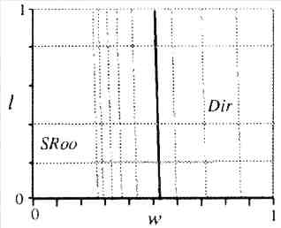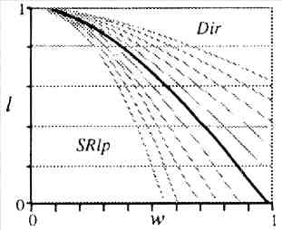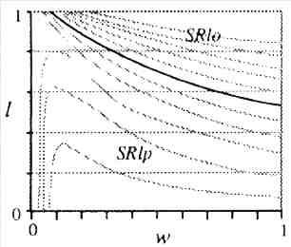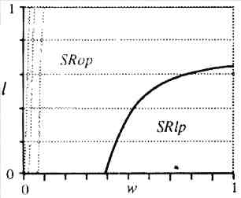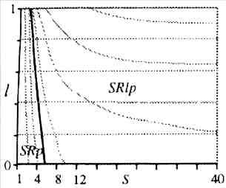

4: Different Software Strategies

There are other strategies out there that are implemented in software other than the basic software strategy and dynamic software strategies we have just talked about. Below are three different strategies: Adaptive, Vectorization, and CAS.

4.1: Adaptive Coherence Strategy

The adaptive coherence strategy is adaptive as its name implies. It adapts to different categories of data. It can do this because it has several different mechanisms at its disposal and can choose the best one. (Bennett, Carter, & Zwaenepoel, 1996) It chooses which of its different mechanisms to use based on either its observations of the program or its expectations. (Bennett et al., 1996) Since all the mechanisms that are part of an adaptive strategy are all software-based mechanisms, the overhead won’t be so bad as to override the good that the authors see the strategy doing. (Bennett et al., 1996)
In order for it to work, a majority of the data must fit into a few categories. These categories are distinguished by what order things are accessed and how often. For example, the authors of the paper have “Write-once, Write-many, Producer-consumer, Private, Migratory, Result, Read-mostly, and Synchronization” (Bennett et al., 1996) as categories. I will describe each of these in a few minutes. These are the categories that control what mechanisms get used. Write-once are, as their name implies, just written once at the beginning and then are only read. Write-many, on the other hand, are being written to a lot. Write-once one doesn’t really need much in the way of coherence. Write-many will be constantly being updated. (Bennett et al., 1996) Producer-consumer is like a data pipe. One thread puts on or produces pieces of data and another takes off or consumes them. On these two threads there would need to be a lot of coherence, but on other threads and other processors not much would be needed if any. (Bennett et al., 1996) Private pieces of data are like the keyword private in Java: they can only be accessed by certain processes. Even though private pieces of data are declared to be shared objects, they can only be accessed by one thread. (Bennett et al., 1996) Migratory means that the object is accessed in phases. When it is accessed, it’s only accessed by one thread. It can be accessed multiple times in a phase, but all the accesses have to be done by one thread. After that, another process accesses it. Thus, the accesses migrate, hence the name. (Bennett et al., 1996) Result means that the piece of data collects, what else, results. It’s very similar to Write-once in that once it’s been written to it can only be read from. However, unlike Write-once, Result can only be accessed by one thread. In that way, they’re a bit like data objects in the Private category. (Bennett et al., 1996) Read-mostly are read “significantly more” (Bennett et al., 1996) than they’re written to. This probably means that these data objects are like Write-many in that they’re written more than once, but only gets written to three or four times for every thousand reads. (Bennett et al., 1996) Then there is the Synchronization category. These are objects that control when other objects are locked and unlocked, which is part of all coherence strategies. (Bennett et al., 1996) Lastly, there’s the other, or “General Read-write” (Bennett et al., 1996) category. This is where an object that can’t be put into one of the other categories gets placed. (Bennett et al., 1996)
There are at two different groups of coherence strategies. The first one is called loose coherence. In loose coherence there are some places where coherence is very important and others where it’s not. Synchronization mechanisms like locks and monitors are put in by the programmer to indicate the places where coherence is important. (Bennett et al., 1996) Loose coherence sometimes has other special things added in to help out. (Bennett et al., 1996) Write-many can use loose coherence if used with delayed updates. These work by waiting after one Write-many object is written to. They delay letting other processors know until it’s possible that they saw the changes and updated their caches themselves (Bennett et al., 1996) . This cuts down on the amount of invalidations traveling around the computer’s network. (Bennett et al., 1996) The other coherence strategy is strict coherence. This is where a program has to have coherence all the time with no inconsistency. (Bennett et al., 1996) The problem with strict coherency is that sometimes it’s used when loose coherency would be okay. This can be inefficient, and can cause something called “false-sharing.” (Bennett et al., 1996)
There are some problems with the Adaptive Coherence Strategy, of course. (Bennett et al., 1996) There’s never such a thing as a perfect strategy. This strategy isn’t able to keep track of how well the different coherence strategies it can use work. Also, there are times when there are a lot of memory accesses. During these times the computer will run slower than when there are only a few accesses. (Bennett et al., 1996)
However, there is a bright side to this. Adaptive coherence greatly cuts down on traffic used to keep caches coherent. This is especially true when delayed updates are used. (Bennett et al., 1996) When a standard software-based cache uses write-update to update the fields in the cache, the improvement can be anywhere from 31% to 52% better. (Bennett et al., 1996) When a software-based cache uses write invalidate, the improvement can go from 35% to 86% better. (Bennett et al., 1996) And that’s just a conservative estimate (Bennett et al., 1996)

4.2: Vectorization Coherence Strategy

Vectorization is used to move operations around in this cache coherence strategy. (Darnell et al., 1992) Because of this, the article claims, the strategy does not invalidate or update cache entries that do not need it. (Darnell et al., 1992) It was not specified by the authors of the article how this is done.
Vectorization also makes it so you don’t have to use interleaving. (Darnell et al., 1992) This means it’s faster than the other schemes it’s compared to.
Sometimes, when the data being cached is a small matrix, other schemes perform better than the Vectorization scheme. (Darnell et al., 1992) .
The comparisons of Vectorization and several other coherence schemes using four different protocols are given in the following diagrams:

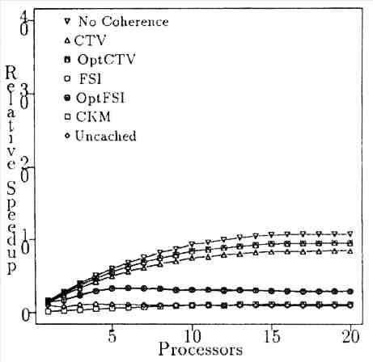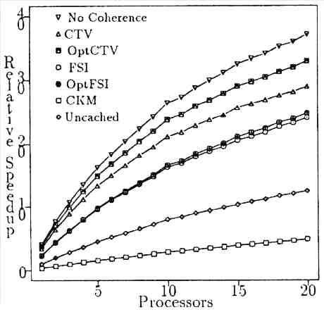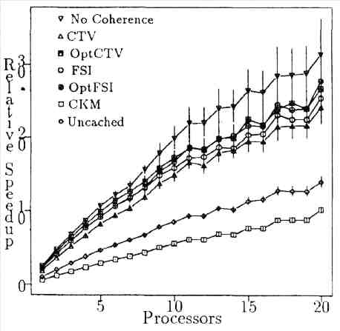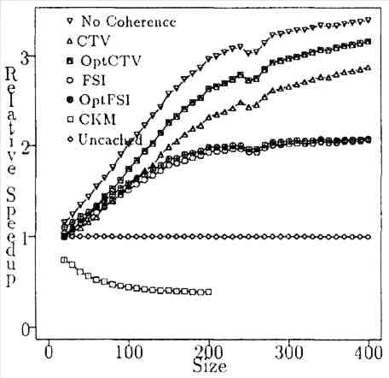

4.3: CAS Coherence Strategy

Cache Affinity Software coherence strategy, or CAS uses something called cache affinity to maintain coherence. (Li & Sevcik, 1994) Cache affinity is also known as temporal locality. (Li & Sevcik, 1994) This in turn is another name for how close they are in time. In other words, are they referenced one right after the other? Is there a gap in time between when the first one is referenced and the second one is referenced?
Some cache coherence solutions do use cache affinity. (Li & Sevcik, 1994) However, they tend to make the scheme more complex than they would need to by adding extra things. (Li & Sevcik, 1994) CAS uses cache affinity, but it doesn’t have any of the extra things that these strategies have. (Li & Sevcik, 1994)
CAS was compared to some other coherence strategies in three different programs. (Li & Sevcik, 1994)
On the first programs used to test the schemes, two of the other schemes don’t do well. They only get a 50% hit ratio. CAS does better. (Li & Sevcik, 1994) How much better is not specified. The results are given in the top graph below:

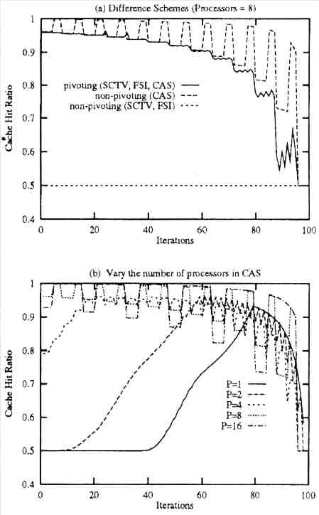

The other graph shows what happens as the number of professors in CAS goes up. When the number of processors is high and the number of iterations is low there’s a good hit ratio. (Li & Sevcik, 1994) This is also true when there’s a high amount of iterations and a low number of processors. (Li & Sevcik, 1994)
In the second program used to test the schemes again the same two coherence schemes as above do not perform well. They get about a 50% hit ratio as before. (Li & Sevcik, 1994) CAS, like before, does better. However, this time it depends on if the cache can hold all of the working set. (Li & Sevcik, 1994) If it can, it does a lot better. If not, it’s not much better. In some cases, its performance is exactly the same as that of the other two cache coherence schemes. (Li & Sevcik, 1994) The graph on the next page shows the results:

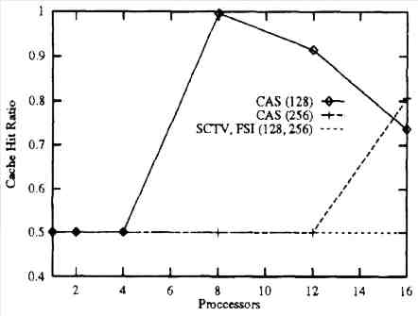

CAS, according to the graph, achieves a 100% hit ratio when there are 8 processors and a matrix size of 128 (Li & Sevcik, 1994) .
In the third program used to test the schemes, again, the other two strategies only achieve a hit ratio of 50%. (Li & Sevcik, 1994) CAS goes from about 70% to 90%. (Li & Sevcik, 1994) The reason for this in this program as well as in the other two is that CAS can use temporal locality while the other two strategies do not. See the graph below:

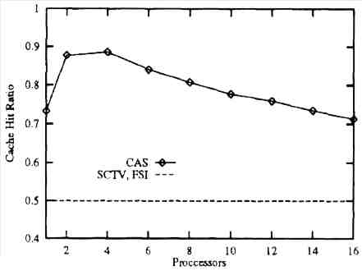

5: Write Policies

One thing that affects the performance of a coherence scheme is the write policy used. (Chen & Veidenbaum, 1992) Write policies control when the data is written to main memory. (Chen & Veidenbaum, 1992) The two most popular are write-through and write-back. Write-through directly writes to main memory. This can make it slow the computer down. However, it also immediately makes the old data in other caches invalid. (Chen & Veidenbaum, 1992) Write-back writes to the cache and then at some future time it sends a bunch of updates to main memory. This means it’s faster, but also requires more work to maintain coherence. (Chen & Veidenbaum, 1992)
Neither one, however, takes care of what to do if there isn’t already a place to write to or an empty space. (Chen & Veidenbaum, 1992) The real problem is, what if you write over something that will be needed again? (Chen & Veidenbaum, 1992) Another write policy, called “write allocate policy” (Chen & Veidenbaum, 1992) takes care of this. Write allocate also gives you the choice of whether you only fetch the one piece of data you originally went for or the whole line. (Chen & Veidenbaum, 1992) It does this partly by always having the valid bit on. (Chen & Veidenbaum, 1992) Some caches don’t have this and each entry has to be marked with a valid bit. (Chen & Veidenbaum, 1992)
Then there’s the write buffer. It takes charge of writing the writes to memory. (Chen & Veidenbaum, 1992) In write-back it waits until it has a bunch and then writes them all at once. (Chen & Veidenbaum, 1992) In write-through, it just makes sure that the writes don’t get in the way of the programs running. (Chen & Veidenbaum, 1992)
Several different combinations of these traits were studied. (Chen & Veidenbaum, 1992) It was found that only three had different types of hit ratios: no-allocate, allocate flush, and allocate no-flush. (Chen & Veidenbaum, 1992) There are five different policies tested: WTNB, WTB, WTWB, WTAWB, and WB. WTNB, WTB, and WTWB all give hit ratios of type no-allocate. (Chen & Veidenbaum, 1992) The other two give a hit-ratio type of allocate flush. (Chen & Veidenbaum, 1992) The last one, allocate no-flush doesn’t have any examples.
The numbers for each category of hit ratio are given in the table below:

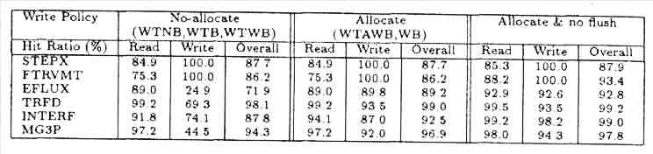

The hit ratios aren’t the only important thing, however. (Chen & Veidenbaum, 1992) Important things like overhead and problems with contention aren’t counted. (Chen & Veidenbaum, 1992) One good way to see which strategies are good and which aren’t is average memory access latency. (Chen & Veidenbaum, 1992)
The worst of the five when using a fast-access system is WTNB because it takes the longest. (Chen & Veidenbaum, 1992) One of the benchmarks used to evaluate the five write policies causes the WB policy to take longer than the others. (Chen & Veidenbaum, 1992) Another benchmark causes WTAWB to perform better than the others. (Chen & Veidenbaum, 1992) The diagram below shows how the five policies compare to each other:

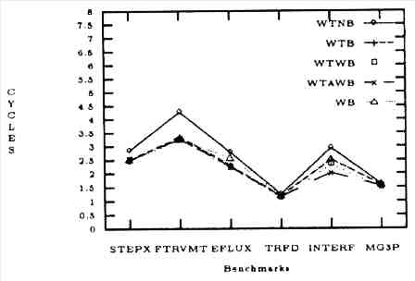

When it’s a slow-access system, WTB doesn’t do very well. (Chen & Veidenbaum, 1992) WB and WTWB also don’t do too well, but they didn’t do well in the fast-access system either. (Chen & Veidenbaum, 1992)

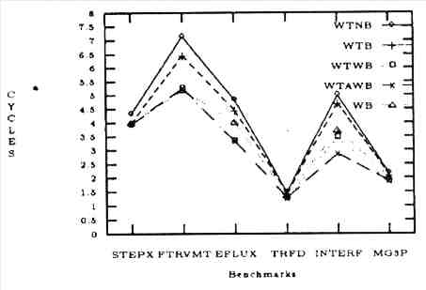

How well a write policy does also depends on how often requests arrive. The faster requests arrive, the more likely contention will be. (Chen & Veidenbaum, 1992) WTB and WTAWB’s contention are compared and WTB has more contention. (Chen & Veidenbaum, 1992)

6: Shared Regions

Shared Regions is a coherence scheme that is related to weak software cache coherence schemes. (Gamsa & Zhou, 1993) Like weak coherence schemes, it uses shared data. (Gamsa & Zhou, 1993) Unlike weak coherence schemes, however, with shared regions this data is cacheable. Also, shared regions doesn’t need more hardware support than a normal software coherency strategy. Other weak coherence schemes do. (Gamsa & Zhou, 1993)
Shared regions are defined as “a set of memory locations that are accessed together (i.e. within the same task) and in the same mode (read or write) in a parallel application.” (Gamsa & Zhou, 1993) This could be anything from one piece of data to all the data accessed in a program.
The programmer can specifically bind a shared region to data. When this happens, the shared region is called a token. (Gamsa & Zhou, 1993)
When shared regions are used as synchronization objects, the irony is that often actual synchronization objects such as semaphores are needed. (Gamsa & Zhou, 1993) The only problem is that semaphores and other similar objects are used to protect code. Shared regions are used to protect memory. (Gamsa & Zhou, 1993) The actual code is quite similar. This can be seen comparing the C++ code for semaphores and for shared regions on the next page:

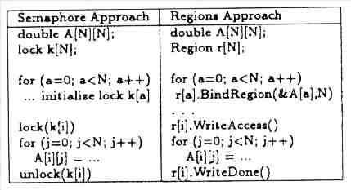

Shared regions is a dynamic strategy: it manages the cache during runtime. (Gamsa & Zhou, 1993) The advantage of this is that compiler-based strategies are conservative. They could think a piece of data was shared and therefore uncacheable. (Gamsa & Zhou, 1993) Shared regions can always cache shared data. (Gamsa & Zhou, 1993) The disadvantage is that there’s some overhead involved. (Gamsa & Zhou, 1993)
In order for shared regions to work well, one of two things must happen. The first option is that the regions must be big enough. The other option is that the data in the shared region must be used a lot by the processor. (Gamsa & Zhou, 1993) It could be that both could occur, which would mean that would be the best of all. (Gamsa & Zhou, 1993)

7: Hybrid Coherence Schemes

There are also hybrid coherence schemes. These schemes combine hardware coherence schemes and software coherence schemes. Supposedly this would yield the best of both worlds. The following are examples of hybrids. We also see if they can really work.

7.1: FLASH

FLASH’s basic programming model is the same as a hardware directory scheme. (Chandra, Gharachorloo, Soundararajan, & Gupta, 1994) The software piece is chosen to be a region-based protocol. (Chandra et al., 1994) This was chosen because it fits best with the hardware. It also gets rid of the problem of false-sharing. (Chandra et al., 1994)
FLASH was compared to the performance of two other protocols. One was your typical hardware protocol. (Chandra et al., 1994) The other was a cache only memory architecture, or COMA. (Chandra et al., 1994)
The results for all three depend strongly on the type of cache misses. Since this is the case, the cache misses were divided up into categories so the effects of the different kinds could be seen. (Chandra et al., 1994) Three of the categories were the three C’s of cache misses: cold, capacity, and conflict. (Chandra et al., 1994) Another was communication. (Chandra et al., 1994) The last two were called local and remote. The difference between these two was whether or not they were satisfied by the local node or whether the processor had to go to a remote one. (Chandra et al., 1994; Hennessy & Patterson, 2003) The local node is another name for the cluster where the processor that makes the request is. (Hennessy & Patterson, 2003) Then, for the hybrid, the remote category was divided in two. (Chandra et al., 1994) The two subsections were called remote-region and remote-other. These two were told apart by whether the data was in a region or not. (Chandra et al., 1994)
COMA performed better than the hardware strategy, called CC. (Chandra et al., 1994) This is because COMA’s cache is bigger than CC’s. (Chandra et al., 1994) This means that there are fewer conflict and capacity misses. (Chandra et al., 1994) This helps with performance.
Hybrid does better than CC as well. (Chandra et al., 1994) Hybrid moves data using bulk transfer and transfers it a region at a time. (Chandra et al., 1994) This gets rid of the remote-region category. (Chandra et al., 1994) Mostly, the misses that would be in this category either become local misses or cache hits. (Chandra et al., 1994)
COMA and Hybrid both cut down on the number of capacity and conflict misses. (Chandra et al., 1994) The difference between them is because of two different things. (Chandra et al., 1994) First of all, Hybrid doesn’t cut down on the number of remote-other misses. COMA does. (Chandra et al., 1994) Secondly, Hybrid cuts down on the number of remote-region misses of cold and communication types. COMA doesn’t. (Chandra et al., 1994) These two differences are caused by Hybrid using its software protocol to do the bulk transfer of data. (Chandra et al., 1994)
Overall, Hybrid and COMA perform better than CC. (Chandra et al., 1994) For two of the four simulation strategies COMA was better than Hybrid. (Chandra et al., 1994) For the other two Hybrid performs better than COMA. (Chandra et al., 1994)
COMA’s gains over CC are because it reduces the amount of times it goes to memory. COMA probably is able to do this because of having a bigger cache than CC. Because of this, COMA can service some of the remote misses as if they were local ones. (Chandra et al., 1994)
Hybrid, like COMA reduces the amount of times a processor goes to memory, but not as much. (Chandra et al., 1994)
See the below table for the data for the three strategies:

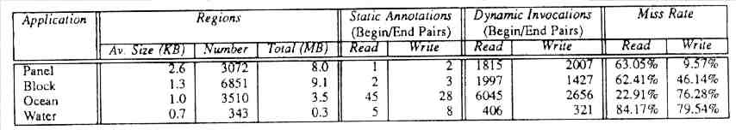

There is one problem with the hybrid scheme. That is that the programmer has to supply some of the information needed to make the hybrid protocol perform its best. (Chandra et al., 1994) COMA doesn’t need this information to be supplied by the programmer. (Chandra et al., 1994) However, the information put in by the programmer is what makes it so the hybrid solution can use bulk transfer for the data. This gives it an improvement over COMA. (Chandra et al., 1994) So it’s a toss-up. It depends on your situation which would be better for your system to use.

7.2: Other

There are three different strategies that I want to cover in this section. None of them are named. I will simply call them hybrid1, hybrid2, and hybrid3.
Hybrid1 rewrites the instructions statically. Instead of a plain store instruction, hybrid1 does an invalidate of the cache and a load as well as the store. (Marathe, Mueller, & Supinski, 2005) This means that there’s a cache miss. The hardware can easily trace this. (Marathe et al., 2005) Hybrid1 also indicates when this has happened to distinguish between a store and an original load miss. (Marathe et al., 2005) Hybrid1 also uses something called “lossy tracing” (Marathe et al., 2005; Marathe, Mueller, & Supinski, 2006) which only traces through small amounts of data at a time. (Marathe et al., 2005) This lowers the amount of overhead needed. (Marathe et al., 2005) Software caches keep track of all memory references without regard to whether they are cache hits or misses. Hybrid1 only keeps track of the cache misses. (Marathe et al., 2005)
Hybrid1 was compared to a traditional software cache coherence scheme. Hybrid1 had a lot fewer accesses than the traditional software strategy. This is because of hybrid1 only tracking the cache misses. (Marathe et al., 2005) Hybrid1 also randomly chooses whether or not to follow a possible cache miss. This cuts down on the trace volume. However, it also makes it so that not all the loads are captured. Some of which have latencies over 8 cycles long, which can slow down the processor. (Marathe et al., 2005) To figure out what stores can be tracked, there are two levels which have to be gotten through. The first is whether it’s dynamic or not. If it is, it’s passed the first stage. The second stage is whether or not it’s a cache miss. If it is, than it is eligible for being tracked. (Marathe et al., 2005)
Hybrid1 uses the concept of “Coverage Fraction” (Marathe et al., 2005; Marathe et al., 2006) and “Number of False Positives” (Marathe et al., 2005; Marathe et al., 2006) . According to the article, coverage fraction “indicates what fraction of the total coherence misses these reference account for in the original results.” (Marathe et al., 2005) Number of false positives “indicates how potentially misleading the lossy-trace based results are.” (Marathe et al., 2005) Hybrid1 performs at its best when coverage fraction is high and number of false positives is low. (Marathe et al., 2005) However, as the size of the sample used goes up, these two values don’t increase or decrease much. (Marathe et al., 2005)
Hybrid2 and hybrid3 are a combination of a dynamic hardware directory scheme and a compiler optimization. (Lilja & Yew, 1991) Hybrid2 uses an optimization called “static marking” (Lilja & Yew, 1991) and hybrid3 uses one called “dynamic marking.” (Lilja & Yew, 1991) Both of these optimizations are used to indicate what data will go stale when. (Lilja & Yew, 1991) Static marking marks the memory addresses it thinks will go stale. Dynamic marking marks memory references that it thinks need a pointer to an address. (Lilja & Yew, 1991)
For both hybrid2 and hybrid3, the hardware is orthogonal. This means hybrid2 could become hybrid3 and vice versa. (Lilja & Yew, 1991)
Hybrid2 can cut down on the size of the directory typically found with a directory-based cache coherence scheme. It also performs well. (Lilja & Yew, 1991) Hybrid3 can do everything hybrid2 can do. However, it can also shrink the directory even further than hybrid2 can. (Lilja & Yew, 1991)
Since hybrid2 and hybrid3 are basically the same just with a different software piece, I will refer to them together as hybrid-2-3 for the rest of this section. This is because they were compared to other non-hybrid schemes and treated as one. The other schemes hybrid-2-3 was compared to were: a traditional directory scheme, a broadcast directory scheme, a linked-list directory scheme, a directory called the n-pointers plus directory scheme, and a software scheme. (Lilja & Yew, 1991)
Hybrid-2-3 has a smaller cache size than the traditional directory scheme, which makes it better. (Lilja & Yew, 1991) Hybrid-2-3 is also better than the linked list directory scheme. That’s because it can’t jump right to the correct spot. It has to go from space to space until it finds the right one. The linked list also requires more memory than hybrid-2-3. (Lilja & Yew, 1991) The numerical results are presented in the table below:

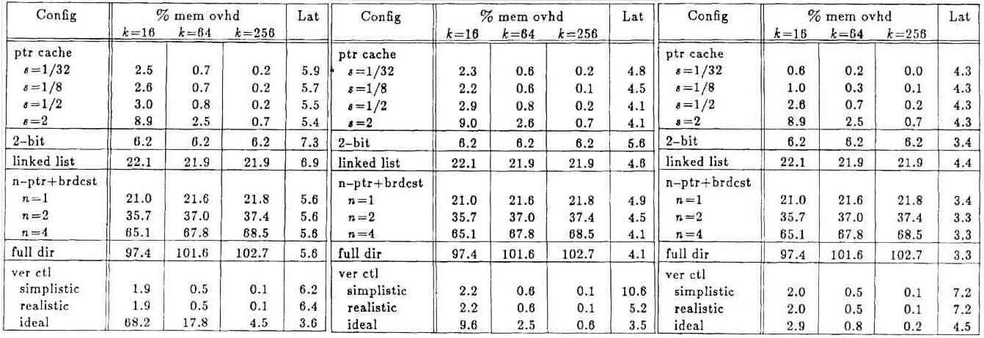

Summary:

In this paper, I started out by comparing and contrasting hardware and software coherence strategies. I had two examples of hardware strategies: snoopy cache or snoopy bus and directory. There was only one example of a software strategy. I showed that hardware coherence strategies were good because they only invalidated what needed invalidating. However, both had to send out a lot of messages in order to maintain coherence. This means a lot of traffic, which can slow the system down. Software strategies are good because they don’t need to send and receive messages except for invalidations. There’s a lot less traffic that way. This means they’re faster than the hardware strategies. However, the typical software coherence strategy is also static. This can cause problems because the invalidations are done when the program is compiled. The compiler has to guess about what’s going to be invalidated. It often overestimates and invalidates more pieces of data than would be necessary. This can slow things down because it means the processor has to go to memory more often.
Then I went to dynamic and static strategies. There were some software strategies I found that were dynamic. One strategy, called column caching, dynamically moved data around in the cache. It used an n-way associative cache, which meant that it had n columns. As long as the data stayed in the set of n spaces, it would still be found. This is an improvement because it lessens the chance of a piece of data being overwritten. The other one has the data invalidates/updates be managed dynamically. There were three different ways of doing this: optimistic, pessimistic, and lazy.
After that came some software cache coherence strategies that were different from the typical software scheme I had used in my comparison of hardware and software. The first one of these was adaptive. It actually had several different schemes it could use. It divided the data up into different categories and then used a different scheme for each category. This had very good results. The second one was the vectorization strategy. This strategy uses vectorization to move the operations around so they perform better. There was pitifully little amount of information on this scheme. The third scheme was called CAS. CAS is a three letter acronym and stands for cache affinity software. This just means it pays attention to how often certain pieces of data are referenced and what other pieces are referenced at the same time or soon after. This keeps data that will be needed next from being booted out. If this happened then the processor would have to go to memory and things would be slowed down.
Then came two things that were important add-ons to software cache coherence schemes. The first one was Write Policies and the other one was Shared Regions. Write Policies talked about strategies to handle what happens when a processor pulls in data from memory. The other one, Shared Regions, talks about a semaphore-like scheme where chunks of data are blocked off. With this scheme, only one processor can access it at a time.
Lastly, I talked about a few hybrids. These are combinations of hardware and software strategies. They take the best of both schemes and combine them. This usually produces a scheme that works fairly well.

References:

Adve, S. V., Adve, V. S., Hill, M. D., & Vernon, M. K. (1996). Comparison of Hardware and Software Cache Coherence Schemes. In I. Tartalja & V. Milutinovic, The Cache Coherence Problem in Shared-Memory Multiprocessors software solutions (pp. ). Los Alamitos, CA: IEEE Computer Society Press.

Bennett, J. K., Carter, J. B., & Zwaenepoel, W. (1996). Adaptive Software Cache Management for Distributed Shared Memory Architectures. In I. Tartalja & V. Milutinovic, The Cache Coherence Problem in Shared-Memory Multiprocessors software solutions (pp. ). Los Alamitos, CA: IEEE Computer Society Press.

Brorsson, M. (1995). SM-prof: A Tool to Visualize and Find Cache Coherence Performance Bottlenecks in Multiprocessor Programs. In Joint International Conference on Measurement and Modeling of Computer Systems Proceedings of the 1995 ACM SIGMETRICS joint international conference on Measurement and modeling of computer systems (pp. 178 – 187). New York, NY: ACM Press.

Chandra, R., Gharachorloo, K., Soundararajan, V., & Gupta, A. (1994). Performance Evaluation of Hybrid hardware and Software Distributed Shared Memory Protocols. In International Conference on Supercomputing Proceedings of the 8th international conference on Supercomputing (pp. 274 – 288). New York, NY: ACM Press.

Chen, Y. C., & Veidenbaum, A. V. (1992). An Effective Write Policy for Software Coherence Schemes. In Conference on High Performance Networking and Computing Proceedings of the 1992 ACM/IEEE conference on Supercomputing (pp. 661 – 672). Los Alamitos, CA: IEEE Computer Society Press.

Cheong, H., & Veidenbaum, A. (1996). A Version Control Approach to Cache Coherence. In I. Tartalja & V. Milutinovic, The Cache Coherence Problem in Shared-Memory Multiprocessors software solutions (pp. ). Los Alamitos, CA: IEEE Computer Society Press.

Cheong, H., & Vaidenbaum, A. V. (1996). A Cache Coherence Scheme With Fast Selective Invalidation. In I. Tartalja & V. Milutinovic, The Cache Coherence Problem in Shared-Memory Multiprocessors software solutions (pp. ). Los Alamitos, CA: IEEE Computer Society Press.

Chiou, D., Jain, P., Rudolph, L., & Devadas, S. (2000). Application-Specific Memory Management for Embedded Systems Using Software-Controlled Caches. In Annual ACM IEEE Design Automation Conference Proceedings of the 37th conference on Design automation (pp. 416 – 419). New York, NY: ACM Press.

Darnell, E., Mellor-Crummey, J. M., & Kennedy, K. (1992). Automatic Software Cache Coherence Through Vectorization. In International Conference on Supercomputing Proceedings of the 6th international conference on Supercomputing (pp. 129 – 138). New York, NY: ACM Press.

Gamsa, B., & Zhou, S. (1993). The Shared Regions Approach to Software Cache Coherence on Multiprocessors. In Principles and Practice of Parallel Programming Proceedings of the fourth ACM SIGPLAN symposium on Principles and practice of parallel programming (pp. 229 – 238). New York, NY: ACM Press.

Hennessy, J. L., & Patterson, D. A. (2003). Computer Architecture: A Quantitative Approach. California: Morgan Kaufmann Publishers.

Li, H., & Sevcik, K. C. (1994). Exploiting Cache Affinity in Software Cache Coherence. In International Conference on Supercomputing Proceedings of the 8th international conference on Supercomputing (pp. 264 – 273). New York, NY: ACM Press.

Lilja, D. (1996). Cache Coherence in Large-Scale Shared-Memory Multiprocessors: Issues and Comparisons. In I. Tartalja & V. Milutinovic, The Cache Coherence Problem in Shared-Memory Multiprocessors software solutions (pp. ). Los Alamitos, CA: IEEE Computer Society Press.

Lilja, D. J., & Yew, P. (1991). Combining Hardware and Software Cache Coherence Strategies. In International Conference on Supercomputing Proceedings of the 5th international conference on Supercomputing (pp. 274 – 283). New York, NY: ACM Press.

Marathe, J., Mueller, F., & Supinski, B. (2005). A Hybrid Hardware/Software Approach to Efficiently Determine Cache Coherence Bottlenecks. In International Conference on Supercomputing Proceedings of the 19th annual international conference on Supercomputing (pp. 21 – 30). New York, NY: ACM Press.

Marathe, J., Mueller, F., & Supinski, B. R. (2006). Analysis of Cache-Coherence Bottlenecks with Hybrid Hardware/Software Techniques. ACM Transactions on Architecture and Code Optimization (TACO), 3(4), 390 – 423.

Min, S. L., Baer, J., & Kim, H. (1990). An Efficient Caching Support for Critical Sections in Large-Scale Shared-Memory Multiprocessors. In International Conference on Supercomputing Proceedings of the 4th international conference on Supercomputing (pp. 34 – 47). New York, NY: ACM Press.

Owicki, S. & Argawal, A. (1996). Evaluating the Performance of Software Cache Coherence. In I. Tartalja & V. Milutinovic, The Cache Coherence Problem in Shared-Memory Multiprocessors software solutions (pp. ). Los Alamitos, CA: IEEE Computer Society Press.

Sandhu, H. (1992). Integrating Applications with Cache and Memory Management on a Shared-Memory Multiprocessor. In IBM Centre for Advanced Studies Conference Proceedings of the 1992 conference of the Centre for Advanced Studies on Collaborative research - Volume 1 (pp. 382 – 393). Toronto, Canada: IBM Press.

Sandhu, H., & Sevcik, K. (1995). An Analytic Study of Dynamic Hardware and Software Cache Coherence Strategies. In Joint International Conference on Measurement and Modeling of Computer Systems Proceedings of the 1995 ACM SIGMETRICS joint international conference on Measurement and modeling of computer systems (pp. 167 – 177). New York, NY: ACM Press.

Shi, W., Hu, W., & Tang, Z. (1997). An Interaction of Coherence Protocols and Memory Consistency Models in DSM Systems. ACM SIGOPS Operating Systems Review, 31(4), 41 – 54.

